PE_PRN212_SU24TrialTest
SUMMER 2024
Subject: PRN212
Duration: 90 minutes (upload the solution within 4 minutes before the deadline – due to the heavy traffic of network)

INSTRUCTIONS
Please read the instructions carefully before doing the questions.
- You are NOT allowed to use any other materials. You are NOT allowed to use any device to share data with others.
- You must use IDE as Visual Studio 2019 or later, MSSQL Server 2016 or later database for your development tools.
IMPORTANT – Before you start doing your solution, MUST do the following steps:
- To do your program, you must use Windows Presentation Foundation (WPF), apply 3-Layer architecture. Note that you are not allowed to connect directly to database from WPF Windows/Pages, every database connection must be used with Repositories and Data Access Objects. The database connection string must get from appsettings.json file. In the case your program connects directly to database from WPF Windows/Pages or you hardcode connection string, you will get 0 point.
- If there are syntax errors or compilation errors in your PE program, you will not pass the PE requirements, the point will be 0.
- Create Solution in Visual Studio 2019/2022 named PE_PRN212_SU24_TrialTest_StudentName. Inside the Solution, Project WPF named: BookManagement_StudentName.
- Create your MS SQL database named BookManagementDb by running code in script BookManagementDb.sql.
- Set the default user interface for your project as Login window/page.
- Your work will be considered invalid (0 point) if your code inserts stuff that is unrelated to the test.

Create an application using Windows Presentation Foundation (WPF) with .NET5/.NET6/.NET7/.NET8, C#, and Entity Framework Core. A MS SQL Server database will be created to persist the data and it will be used for reading and managing data.
The below Figure is a part of BookManagementDb database.
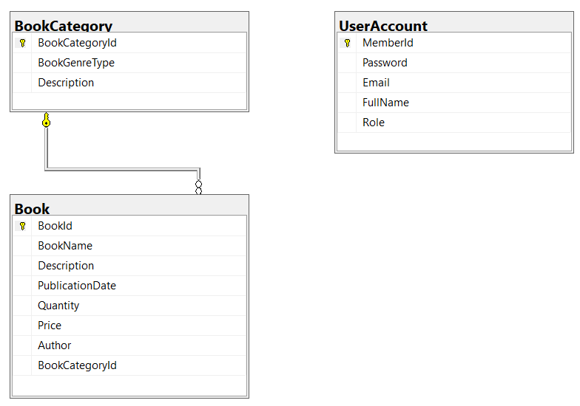
Note that: User role: Administrator = 1; Staff = 2; Member = 3. A book category will have many books, a book will belong to only one book category.

Task 1. Design graphic user interface
- (0.5 point) Design Login Window includes UI controls for login function.
Object Type | Properties
Window | Title: Login Window  Height: 330  Width: 600  FontFamily: Arial  FontSize: 14  Background: #FFD4F7D4  WindowStartupLocation: CenterScreen
Label | Font: Arial Narrow, 12pt  ForeColor: 0,0,255
TextBox | TextAlign: Right

- (1.0 point) Design Book Management window, this window includes UI controls for CRUD actions with book information. Note: The BookCategoryId/BookGenreType will come from the BookCategory table. Design a window which allows you to view the list of records, create a new item, update the existing item, and delete a specific item.

Object Type | Properties
Window | Title: Main Book Management Window  Height= 500  Width= 800  FontFamily= Arial  FontSize= 14  Background= #FFD4F7D4  WindowStartupLocation= CenterScreen
Label | Font: Arial Narrow, 12pt  ForeColor: 0, 0, 255  TextAlign: Left
TextBox | TextAlign: Right  ForeColor = Blue

Task 2. Implement CRUD actions with GUI.
- (1.0 point) Authentication function
If user with a Administrator or Staff role logs in successfully (using email address/password for login process), save this information to a temporary parameter. All CRUD actions are required authentication with Administrator role. In the case login unsuccessfully, display “You have no permission to access this function!”.
- (1.5 points) Check if login successfully with Administrator or Staff role, list all books in Book table (the information includes BookId, BookName, Description, PublicationDate, Quantity, Price, Author, BookCategoryId and BookGenreType – book category name).
- (1.0 point) Check if login successfully with Administrator or Staff role, search book information by BookName or Description (using relative search).
- (1.0 point) Check if login successfully with Administrator role, delete the selected item with the confirmation then update the list of books.
- (2.5 points) Check if login successfully with Administrator role, add new item with the requirements:
- The BookCategoryId/BookGenreType (book category id, book genre type) will come from the BookCategory table (you can use ComboBox UI control in this case)
- All fields are required.
- Value for Price and Quantity is greater than or equal to 0 and less than 4 000 000.
- Value for BookName (the name of the book) is in the range of 5 – 90 characters. Each word of the BookName must begin with the capital letter. BookName is also allowed with special characters.
- (1.5 points) Check if login successfully with Administrator role, update an existing item.
- You can use your different window or use the data grid view for this update function (update by BookId).
- With update function, the same validation requirements with Add function.

